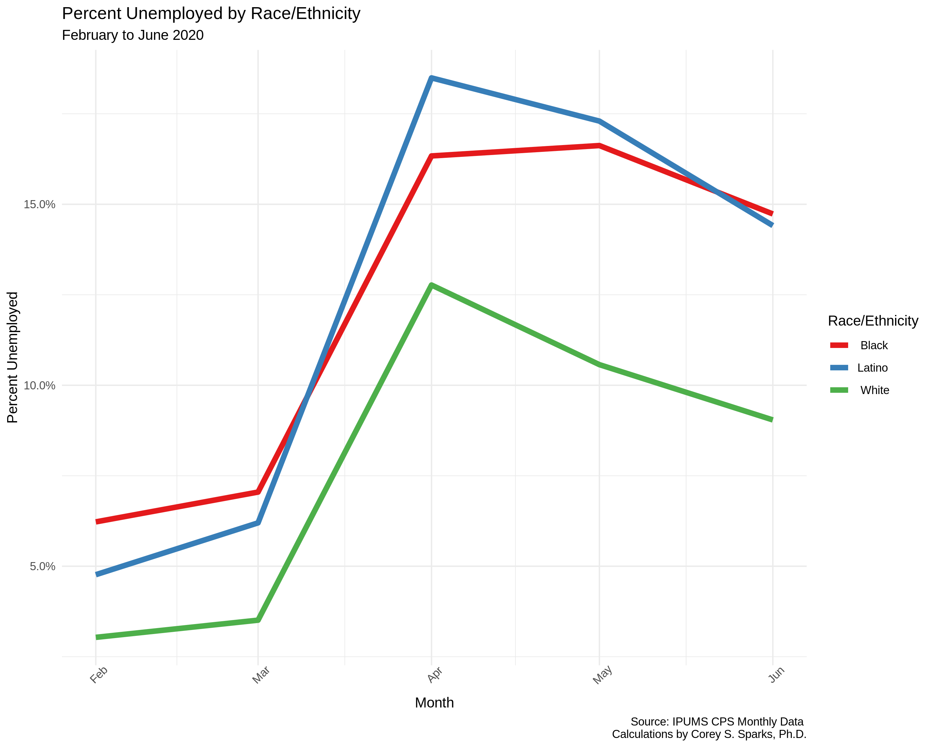
Figure 1. Unemployment rates by race/ethnicity from December, 2019 to June, 2020
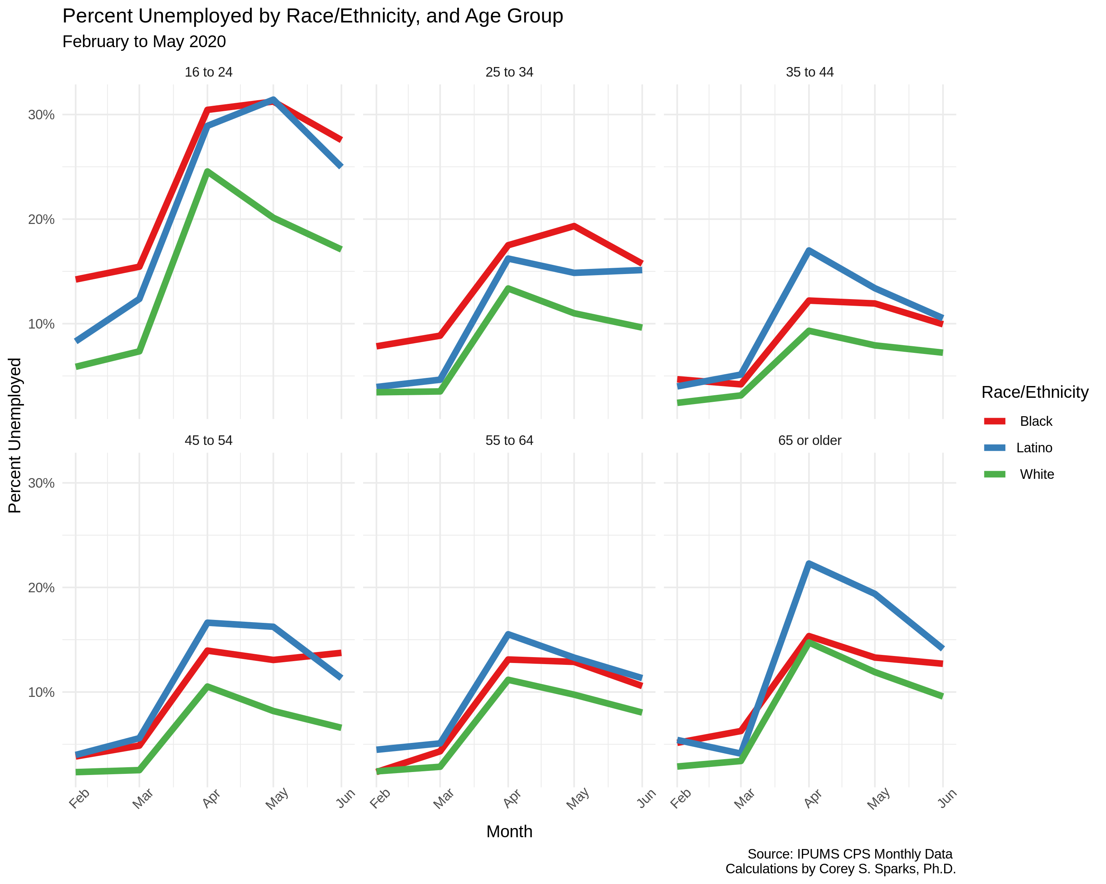
Figure 2. Unemployment rates by Age and race/ethnicity from December, 2019 to June, 2020.

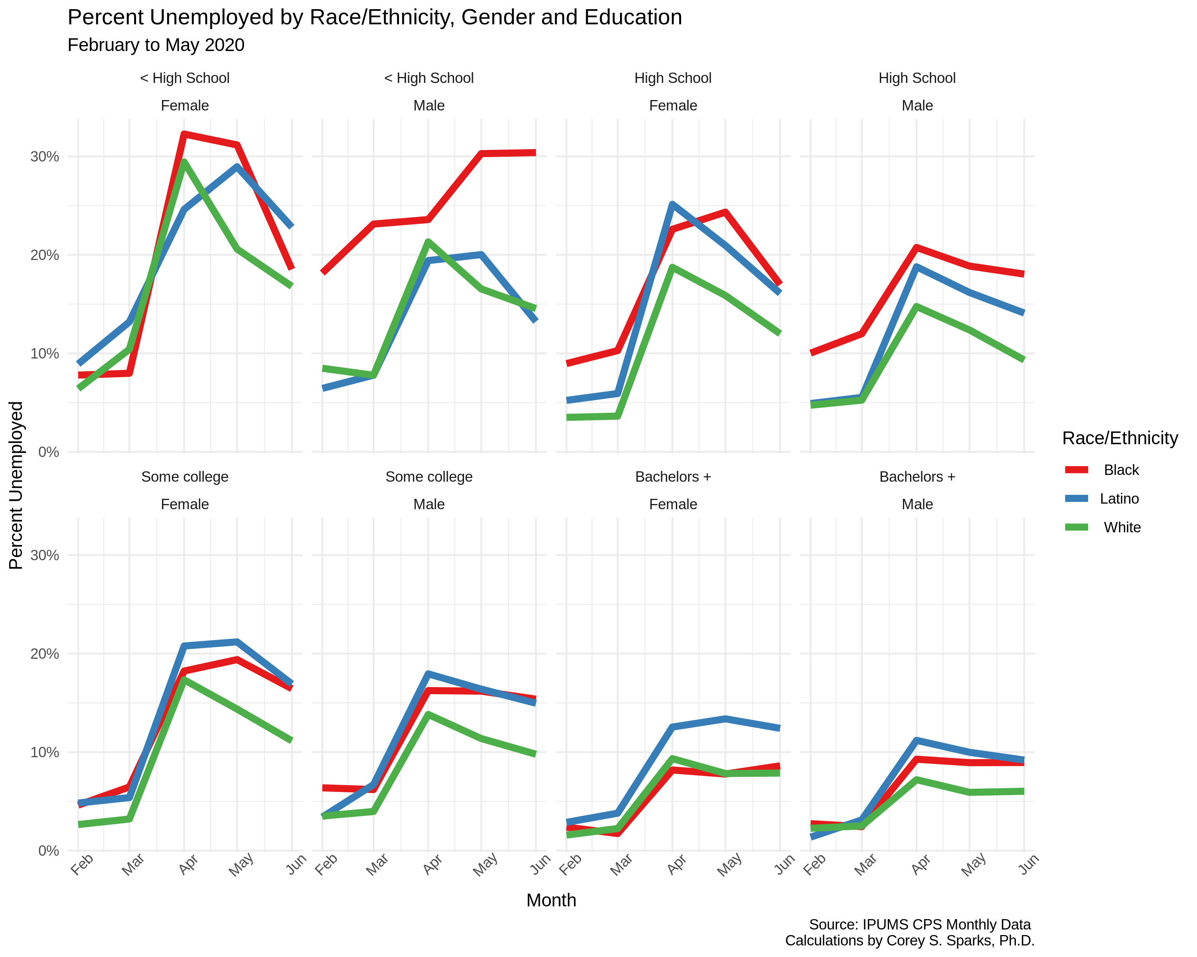
Figure 3. Unemployment rates by Education level and race/ethnicity from December, 2019 to June, 2020.

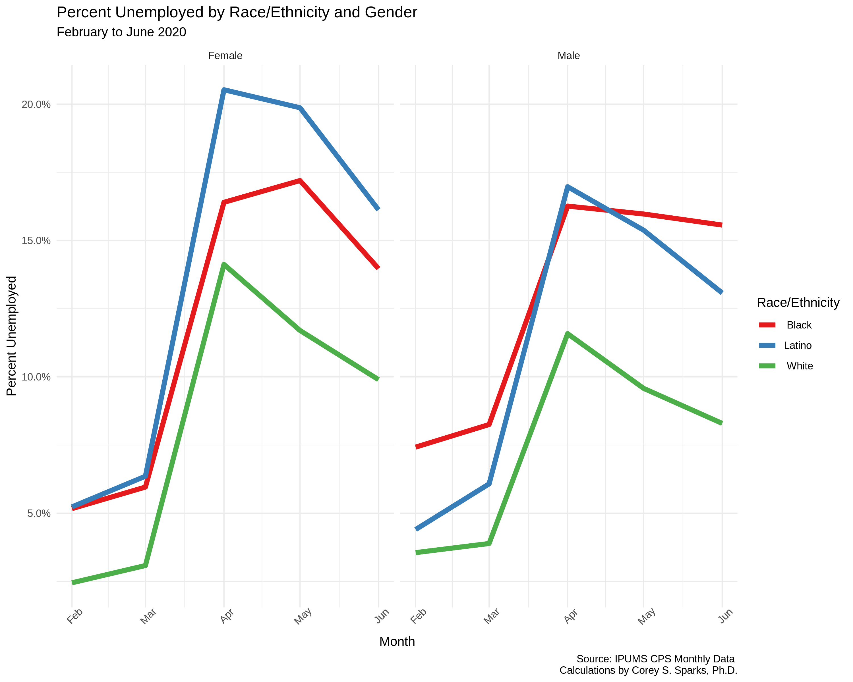
Figure 4. Unemployment rates by gender and race/ethnicity from December, 2019 to June, 2020.

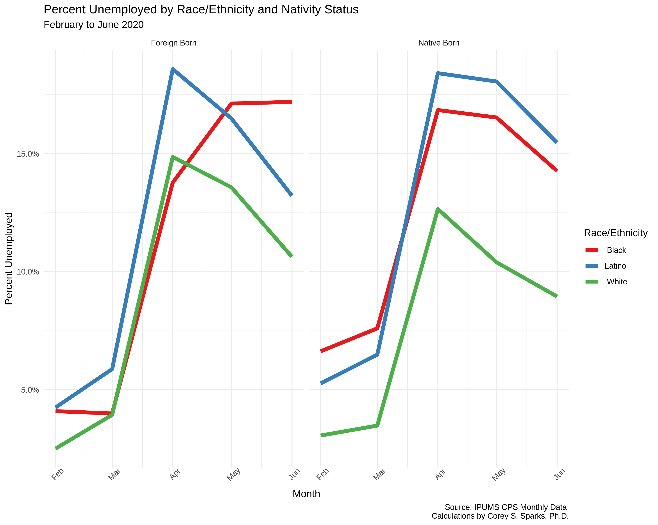
Figure 5. Unemployment rates by Nativity Status and race/ethnicity from December, 2019 to June, 2020.

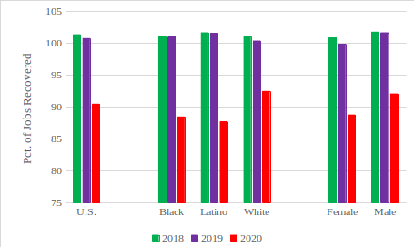
Figure 6. Job Recovery Rates for the U.S. and by Race/Ethnic and Gender Groups, 2018-2020

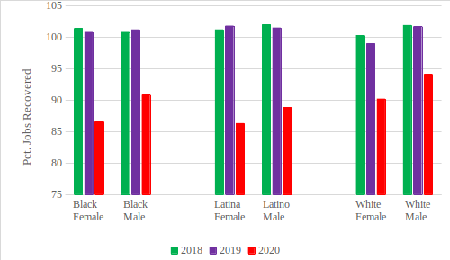
Figure 7. Job Recovery Rate by Race/Ethnic and Gender Group, 2018-2020

